**Analysis of Voter Behavior in U.S. Elections**

**Introduction**

**This report analyzes voter behavior in the U.S. elections of 2020 and 2024 using a dataset that captures various demographic factors, political affiliations, and voting outcomes.**

**Dataset Overview**

* **Voter ID: Unique identifier for each voter.**
* **Election Year: The year of the election (2020, 2024).**
* **Age Group: Age range of the voter (e.g., 18-24, 25-34).**

**Analysis Questions and Findings**

**1. Voter Preference by Age Group**

**Analysis Method: A pivot table was created with age groups as rows and election years as columns, counting the vote outcomes.**

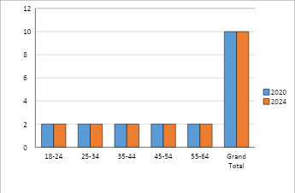

**2. Impact of Education Level on Voting**

**Analysis Method: A pivot table was set up with education levels as rows and political parties as columns, counting the vote outcomes.**

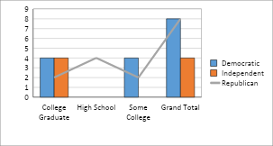

**3. Gender Differences in Voting Outcomes**

**Analysis Method: A pivot table was created using gender as rows and political parties as columns, counting the vote outcomes.**

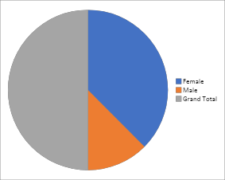

**4. Shifts in State Support**

**Analysis Method: A pivot table was established with states as rows and election years as columns, counting the vote outcomes.**

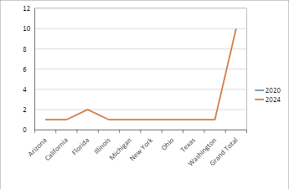

**Challenges**

1. **Data Limitations: The dataset may not capture all relevant factors influencing voter behavior,**
2. **Changing Political Landscape: Voter preferences can shift rapidly due to emerging issues,**

**Conclusion**

**The analysis reveals important trends in voter behavior in the 2020 and 2024 elections. Key insights include shifts in preferences among different age groups,**

**References**

1. ***Abrajano, M. A., & Alvarez, R. M. (2010). Assessing the Causes and Effects of Political Trust Among U.S. Latinos. American Politics Research, 38(1), 110–141.***
2. ***Adona, N., & Gronke, P. (2018). Understanding the Voter Experience: The Public’s View of Election Administration and Reform. Retrieved from Democracy Fun***